**Name – Parag Gattani**

Program No. – 15

Program Title – RGB LED

**AIM**

Design a smart irrigation system (Potentiometer, Servo motor shaft).

**HARDWARES REQUIRED**

* Arduino Board, Breadboard Small
* LED RGB, LCD 16x2, Resistor

**CIRCUIT DIAGRAM**

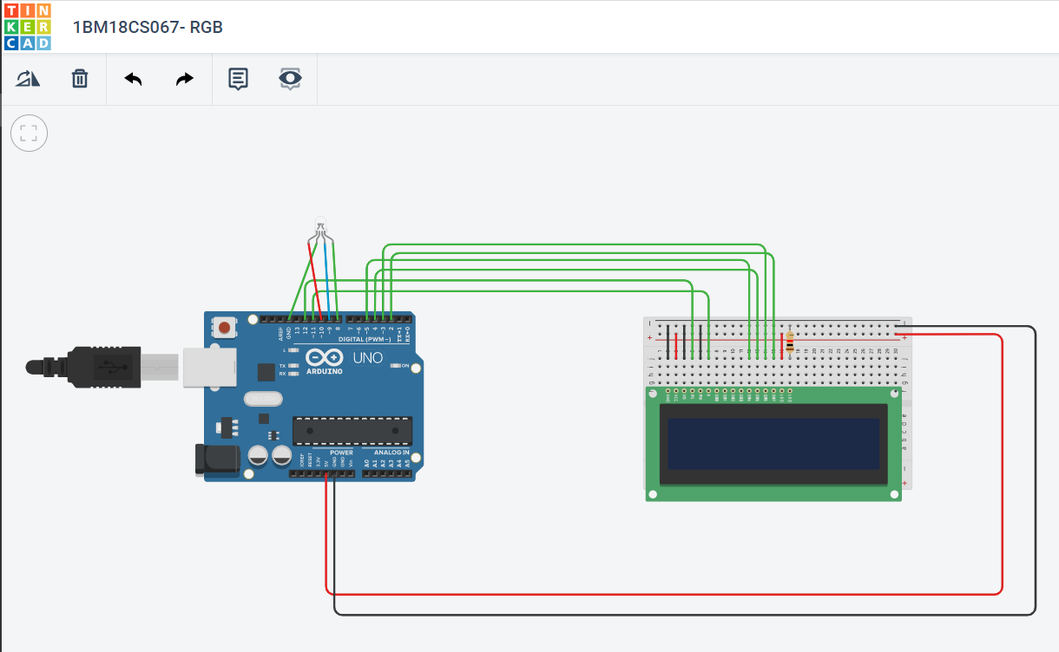

**WRITE-UP**

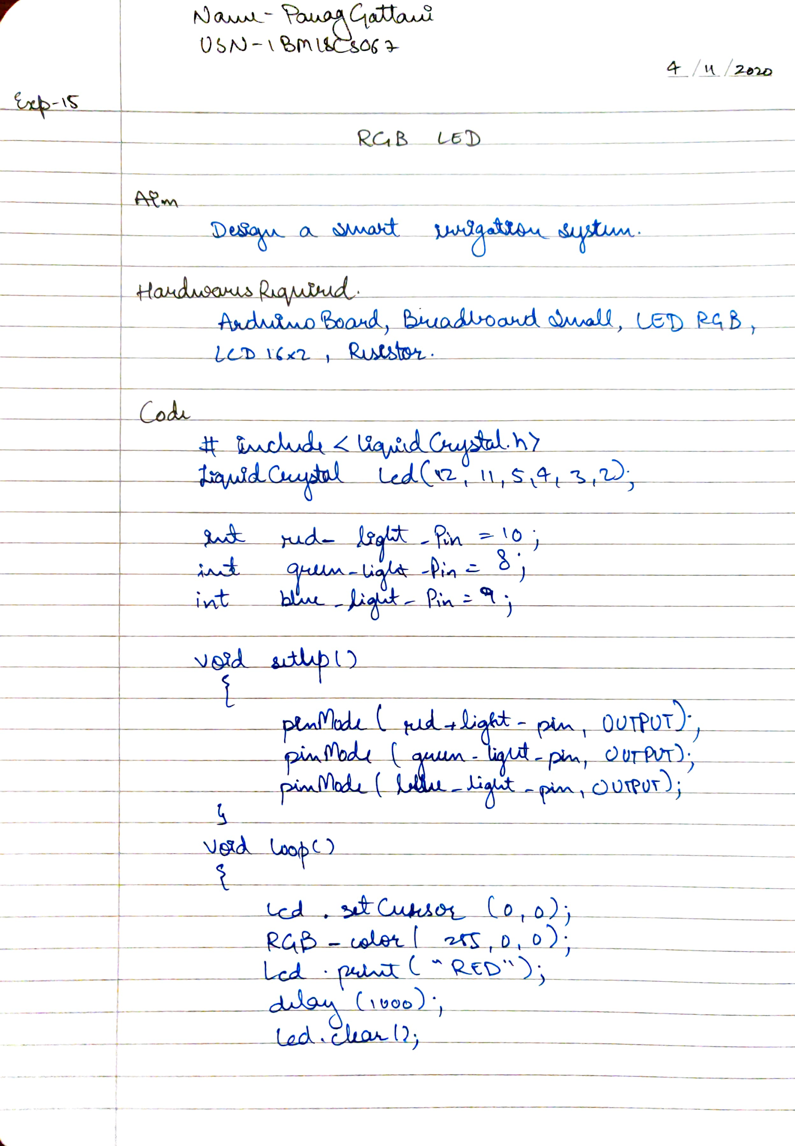

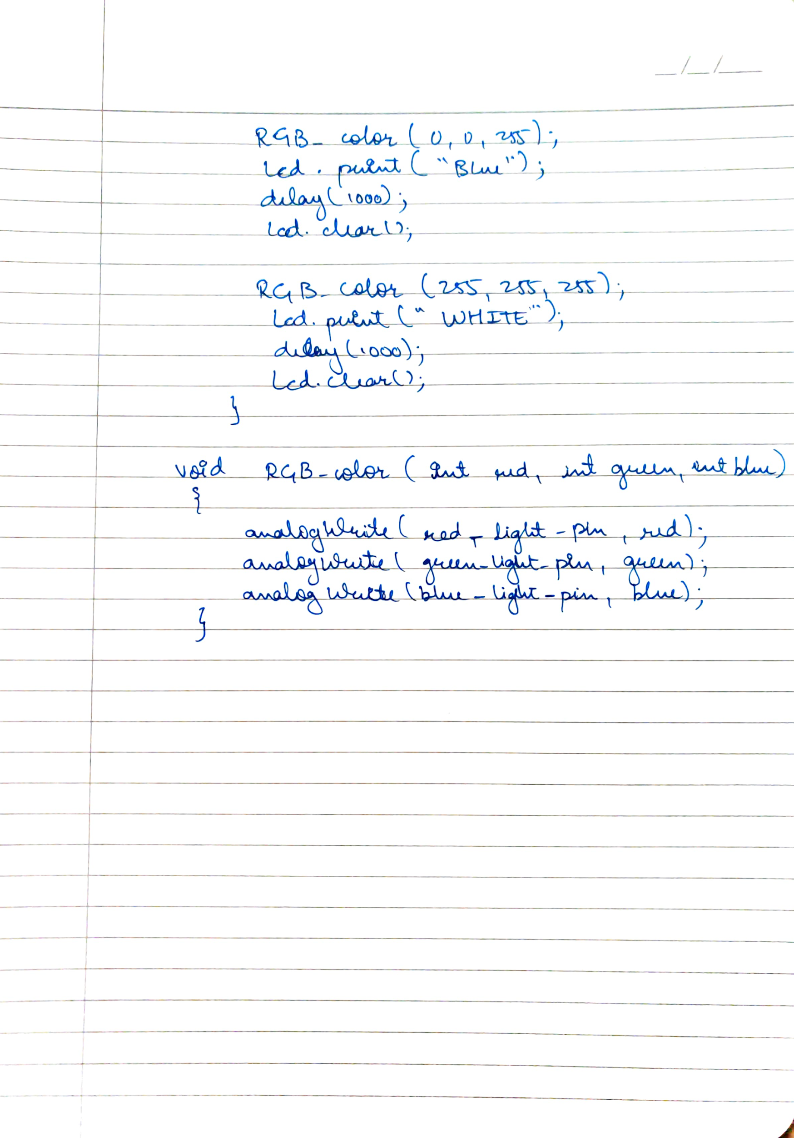

**CODE**

#include <LiquidCrystal.h>

LiquidCrystal lcd(12, 11, 5, 4, 3, 2);

//Parameters: (rs, enable, d4, d5, d6, d7)

int red_light_pin= 10;

int green_light_pin = 8;

int blue_light_pin = 9;

void setup() {

pinMode(red_light_pin, OUTPUT);

pinMode(green_light_pin, OUTPUT);

pinMode(blue_light_pin, OUTPUT);

}

void loop() {

lcd.setCursor(0,0);

RGB_color(255, 0, 0); // Red

lcd.print("RED");

delay(1000);

lcd.clear();

RGB_color(0, 255, 0); // Green

lcd.print("GREEN");

delay(1000);

lcd.clear();

RGB_color(0, 0, 255); // Blue

lcd.print("BLUE");

delay(1000);

lcd.clear();

RGB_color(255, 255, 255); // White

lcd.print("WHITE");

delay(1000);

lcd.clear();

}

void RGB_color(int red_light_value, int green_light_value, int blue_light_value)

{

analogWrite(red_light_pin, red_light_value);

analogWrite(green_light_pin, green_light_value);

analogWrite(blue_light_pin, blue_light_value);

}

**OUTPUT**

Designed a smart irrigation system (Potentiometer, Servo motor shaft).